T3 Engineer Candidate Exercise

Nov' 8th, 2022.

Dror Granot.

Small preview ☺,

I will attach small notes regarding exercises and answers to try and explain myself a bit better.

I did try to stick with the 3-4 hours completion time margin to truly show not only skills but how well I can put them to work in that time frame.

Thank you for the opportunity and an super interesting assignment and I hope it will show enough potential for me to join and grow with you.

Best regards, enjoy.

**SECTION 1 – SQL**

** SQL isn’t my strong side, most of my career I have worked with non relational databases so I answered all the given questions as a challenge, I do need a refresh.

**Part1:**

SELECT class

FROM courses

GROUP BY class

HAVING count( distinct student ) >=5;

**Part2:**

**Q1 –**

SELECT entry_id

FROM entry

WHERE partner_id = 2264441 AND status = 2

**Q2-**

SELECT entry.id

FROM entry

WHERE entry.partner_id = 2264441 AND entry.status = 2

AND entry.created_at

BETWEEN '2018-02-01' AND '2018-02-28'

**Q3-**

SELECT entry.id, entry.name, COUNT(flavor.id) AS flavor_count

FROM entry

LEFT JOIN flavor ON entry.id = flavor.entry_id

WHERE entry.partner_id = 2264441 AND entry.status = 2

GROUP BY entry.id

**Q4-**

SELECT entry.id, entry.name, flavor.id

FROM entry

INNER JOIN flavor ON entry.id = flavor.entry_id

WHERE entry.partner_id = 2264441 AND entry.status = 2

**SECTION 2 – Shell question / Bash Script**

**I do have a basic Shell scripting knowledge to answer this question but I probably lack depth.

cat words.txt | tr -s ‘ ‘ ‘\n’ | sort | uniq -c | sort -r | awk ‘{print $2, $1}’

**SECTION 3 – Java Script**

Please see attached zip named (sec3)

**SECTION 4 – KMC Functionality**

1.

A. After a successful login, you will shown the entries list. 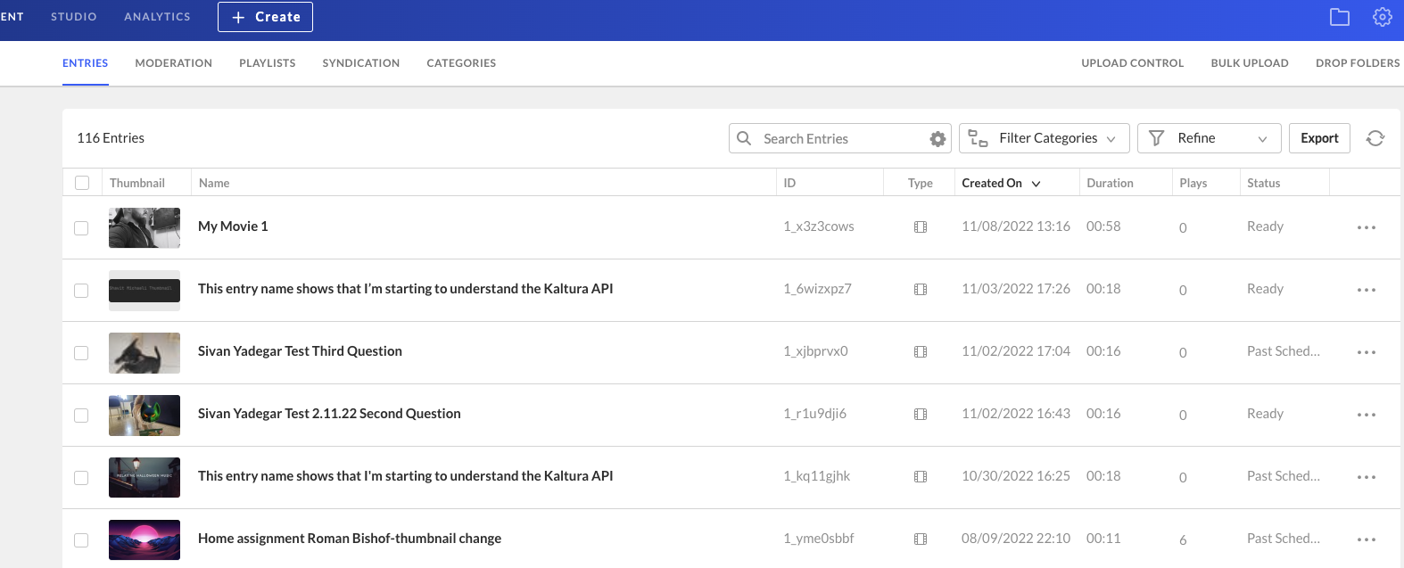

B. Next, on the top right side, on the navigation bar, click on the gear symbol





C. Beneath the tabs, in faint gray, there is a line with the account’s relevant info .

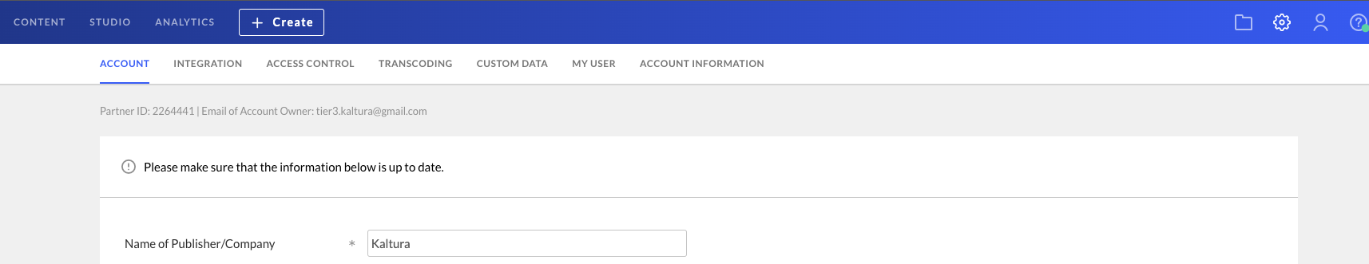



Other option is to click on the INTEGRATION tab, there the relevant information will be shown.

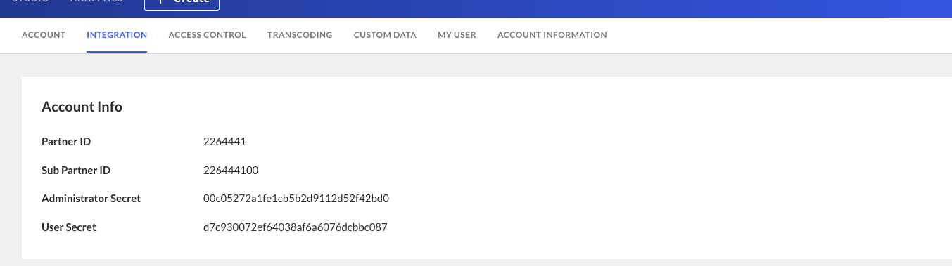



**2. video id :** 1_kq11gjhk

**3. video id :** 1_kq11gjhk

**SECTION 5 – API and network debugging**

1. done ☺

2.

*Entry name - Sivan Yadegar Test Part 2 HTML page building

*Duration 18sec /0.3336 min

*Width 368 (guessing px)

*Flavor params 0,301991,487041,487051,487061,487111

*Status 2

*Moderation status 2 (MODERATED) (thanks for the doc)

*Creation time 1667489181 (unix), Thursday, November 3rd 2022, 5:26:21 pm (est)

Iv'e used tsetse, service- BaseEntry, action- getById.

3.

service- baseEntry, action- update, KalturaBaseEntry Edit. -> name

4. Please refer to the attached video

**SECTION 6 – Kaltura API**

** I have encountered issues with the provided ids so I did my best, unfortunately due to computer technical issues im doing this home task late at night so asking for help isn’t an option but.. lets make lemonade

Q1 - I couldn’t find the provided id, not in KMC and not via TESTME, but if I need to make an educated guess, the code filters by status and type, my educated guess is that the provided id does not fit in this queries, I would remove the filters and run it again.

Q3-

var category = {objectType: "KalturaCategory"};

category.name = "kalturaTest";

category.parentId = 2264441;

category.defaultPermissionLevel = 1 /* KalturaCategoryUserPermissionLevel.MODERATOR */;

KalturaCategoryService.add(category)

.execute(client, function(success, results) {

if (!success || (results && results.code && results.message)) {

console.log('Kaltura Error', success, results);

} else {

console.log('Kaltura Result', results);

}

});

**SECTION 7 – Write Script/Code**

* 2013-01: expected revenue: $0, expected total capacity of the unreserved offices: 0

* 2013-06: expected revenue: $2500, expected total capacity of the unreserved offices: 4

* 2014-03: expected revenue: $3200, expected total capacity of the unreserved offices: 6

* 2014-09: expected revenue: $0, expected total capacity of the unreserved offices: 0

* 2015-07: expected revenue: $0, expected total capacity of the unreserved offices: 0

Please refer to the attached zip named csvproj.

Npm install, npm start, pick a date and upload the csv!

Even thou other languages have much shorter way, due to the job being Frontend oriented, I have approached the task with the most popular FE framework with the most popular FE language, nothing super amazing, just picked the relevant tools.

Took me a bit of time to figure out how to handle csv with only frontend tools and js,

The R&D regrades manipulating csv took the most, if I would be given more time I would mostly change the html scheme to form formation with verifications and make it less ugly ☺.